
Year 3/4
Geography
The Rhine and the Mediterranean

Key Vocabulary
source | where a river begins
mouth | where a river meets the sea
tributary | a river or stream flowing into a larger river or lake
port | a place where ships load and unload
import | to bring in from another country
export | to send to another country
canal | a channel of water made by humans for boat transportation
lock | a lock lets a ship move safely from one level of water to another
peninsula | a piece of land that is almost (but not quite!) surrounded by water
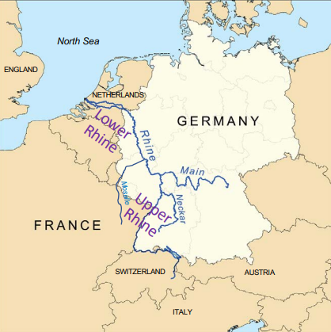
Map of the Rhine.

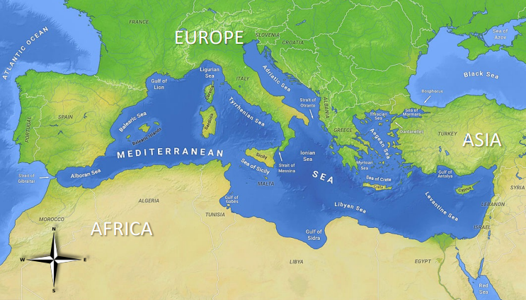
Map of the Mediterranean Sea.

